

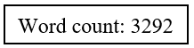

**The following students contributed to the preparation of this group investigation report:**

1. Student 1 [REDACTED]
2. Student 2 [REDACTED]
3. Student 3 [REDACTED]

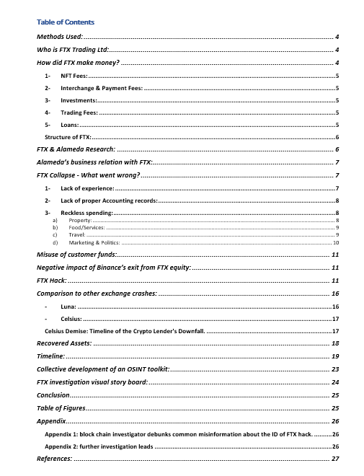

# **Methods Used:**

To ensure anonymity while investigating and accessing the open sources of information available online, the following techniques were implemented/used:

1. Socket Puppet Accounts (Harvey Hughes, James Holbrook, and
2. VPN
3. Virtual Machine
4. TOR Browser
5. Extensions - ‘Privacy Badger’ – (Figure 2) and ‘DuckDuckGo’ – (Figure 3)



# **Who is FTX Trading Ltd?**

FTX Trading Ltd., commonly known as FTX (short for "Futures Exchange"), is a bankrupt company that formerly operated a cryptocurrency exchange and crypto hedge fund. The exchange was founded in 2019 by Sam Bankman-Fried and Gary Wang and, at its peak in July 2021, had over one million users and was the third-largest cryptocurrency exchange by volume. FTX is incorporated in Antigua and Barbuda and headquartered in the Bahamas. FTX is strongly associated with FTX.US, a separate exchange available to US residents (Globalny, 2022; Wikipedia,2023).

# **How did FTX make money?**

The trading interfaces and advanced features of FTX's trading platform were well-known, and these capabilities included customised charting, as well as advanced order types such as stop-limit orders and trailing stops. The platform's low latency, high throughput, and high availability were created with the intention of giving users a seamless trading experience (Hendelmann, 2022). Together with its trading platform, FTX also provided a variety of learning tools, including a blog and a podcast, to aid users in honing their trading abilities and understanding of the cryptocurrency market. The Miami Heat, Oakland Athletics of Major League Baseball, and TSM, an esports team, are just a few of the prominent sports teams that the firm has sponsored (Smith,2023).

Other methods used by FTX to make money:

## NFT Fees:

Users can manufacture, hold, authenticate, and trade digital collectables on FTX's very own NFT (Non-Fungible Tokens) platform, known as FTX NFTs, which was introduced in September 2021. (2022) Hendelmann (Smith, 2023).

## Interchange & Payment Fees:

Users of FTX have the choice to get a physical, Visa-capable debit card that could be connected to their account and used to make purchases. If a user's account did not have enough USD to cover the purchase amount, FTX would convert other coins held in the account. Interchange fees, which are normally paid by the merchant and are in the neighbourhood of one per cent, were what made FTX's debit card profitable. These fees were likely split between FTX and Visa, with the card issuer receiving a percentage (Hendelmann, 2022; Smith, 2023).

## Investments:

FTX had also started to invest extensively in other blockchain and cryptocurrency firms. It can finally sell them off for a profit at a later liquidation event once the value of its shares rises (such as a secondary sale or IPO). (Smith, 2023; Hendelmann, 2022).

## Trading Fees:

The various fees charged whenever consumers trade on FTX's platform made up the majority of its income. For all futures and spot market transactions, FTX used a tiered charge structure (Hendelmann, 2022; Smith, 2023).

## Loans:

Through its over-the-counter trading option, FTX offered credit lines to its most seasoned traders. Traders who met certain conditions—which varied for each application—could submit a loan request. Based on variables including the amount of collateral the trader provided, their prior trading history, and other considerations, FTX then received interest on those loans. No specific information about the interest rate was provided (Hendelmann, 2022; Smith, 2023).

## **Structure of FTX:**

FTX consists of more than 100 interconnected entities, including companies, partnerships, investment vehicles, and subsidiaries that operate under the control of Mr Bankman-Fried. These entities are in various countries and are subject to different legal and tax regulations, creating a complex and sprawling network.

FTX, comprised of several highly-educated individuals, most of whom had a peculiar link – graduates from Massachusetts Institute of Technology (MIT), see Figure 5 below.



Figure 1FTX's Executives (Khun et al., 2022)

# **FTX & Alameda Research:**

# 

Sam Bankman-Fried, the CEO of FTX, and Tara Mac Aulay co-founded Alameda Research in September 2017 as a quantitative trading company after he left his position at Jane Street Capital. According to a 2021 interview, the word "research" was added to the name to evade detection. According to Bankman-Fried, "If you named your company like We Do Cryptocurrency Bitcoin Arbitrage Transnational Things, no one's going to grant you a bank account. But according to Globalny (2022), everyone desires a research institute (Wikipedia,2023). In order to profit from the greater price of bitcoin in Japan compared to America, Bankman-Fried set up a trade in January 2018. Before the price differential closed in early 2018, he made between $10 million and $30 million.

Early in 2019, the company relocated its headquarters from California to Hong Kong, and by August 2021, Bankman-Fried owned roughly 90% of Alameda Research (Globalny, 2022; Wikipedia, 2023).

Alameda Research and FTX have an unusual relationship because of their close ties to the individuals in charge of FTX, many of whom have ties to MIT. After starting her career as a trader at Jane Street, Caroline Ellison, the former CEO of Alameda Research, went to Alameda Research after meeting Bankman-Fried. Her mother and father both teach economics at MIT: Glenn Ellison is a professor of economics there (Khun et al., 2022; Binance, 2022).

Trabucco joined Alameda Research as a trader in 2019 and was appointed CO-CEO in October 2021 with Ellison after Bankman-Fried resigned. He met Bankman-Fried at a math camp in 2010 and later studied math and computer science at MIT (Khun et al., 2022; Block.cc,2022).

# **Alameda’s business relationship with FTX:**

According to the Financial Times, a year before FTX's demise, SBF treated both of his trading behemoths (FTX and Alameda Research) as one, and whenever one was stressed, he would shift the burden to the other (Oliver and Shubber, 2022).

FTX customers were directed to send funds to an account controlled by Alameda, creating an additional $8 billion in liabilities; they were unintentionally contributing to what the SEC called “personal piggy banks" (Mishara and Schickler, 2022).

SBF was charged by the Securities and Exchange Commission in 2022 with covert transfers of FTX customers' money to Alameda Research LLC, preferential treatment on the FTX platform, and undisclosed risk related to Alameda's holdings in overpriced, illiquid assets, including FTX-affiliated tokens.

# **FTX Collapse - What went wrong?**

In November 2022, over a period of 10 days, FTX went from the third-largest cryptocurrency exchange in the world to a bankrupt and collapsed corporation. But what went wrong…

## Lack of experience:

The most worrying factor in FTX's failure was the breakdown of corporate governance, which raised questions about the reliability of cryptocurrency outside the company. Several factors led to FTX's demise. The main cause of the failure was a lack of efficient management processes and internal controls. To run efficiently, all firms must have formal processes and controls in place, including experienced management, outside help, set policies and procedures, risk management, and board oversight. Important internal controls include the proper division of work, management oversight, and transactional controls. If FTX had implemented and tested internal controls, the bankruptcy might have been avoided.

FTX was a "utter failure of corporate controls at every level of an organisation," according to John Ray, the newly appointed CEO after FTX's bankruptcy ("FTX Was a 'Utter Failure of Corporate Controls at Every Level of an Organisation,' Says New CEO," 2022). FTX committed a serious error by operating without clear leadership and organisation while placing inexperienced individuals in key positions. For instance, Constance Wang joined FTX as the Chief Operational Officer, a high-profile role, with just two years of experience in high-profile risk management after graduating from university (2022).

Comparatively, John Ray added, "Never in my career have I witnessed such a comprehensive lack of corporate controls and such a complete absence of reliable financial information as transpired here" (J. Brooks, 2022). According to interviews with workers who remained at FTX until its final days, it was "chronically understaffed and lacked the most fundamental security procedures and financial controls" (Oliver et al., 2022).

The collapse was also heavily impacted by the relationship with Alameda Research, the proprietary trading arm of FTX, highlighting the value of transparency and effective third-party risk management. Alameda Research's financial statement showed a significant amount of FTT, a coin created by the creator of FTX, making approximately 40% of its total assets (McKenna, 2022).

## Lack of proper Accounting records:

FTX was a privately held firm and was exempt from disclosure requirements. FTX's stated lack of an accounting department, together with its lavish spending and dubious management choices, may have contributed to its financial difficulties.

The bankruptcy report made it clear that FTX had a serious issue with maintaining financial records. Due to an incomplete list of bank accounts and signatories, as well as a lack of consideration for the creditworthiness of banking partners, the company lacked effective control over its cash. The precise quantity of cash held by FTX Group is still unknown as a result of these mishaps. Another issue was the business's use of an insecure group email account to access private keys and sensitive information for numerous FTX Group entities globally (Calhoun, 2022).

## Reckless spending:

### Property:

FTX reportedly spent over $250m in the purchase of more than 35 properties in the Bahamas (Goswami, 2022). This is consistent with Daniella (Dani) Cloud's account, a verified ex-employee who detailed how FTX staff members routinely had parties in the lavish condos owned by the business on Twitter. These were "facilities" that workers in the Bahamas could use for free accommodation. Dani added that all hotel stays at expensive properties, including those run by FTX, were covered by the company.

A number of sources were used to verify Dani Cloud's Twitter thread, including an Apple Podcast by 'TH3LAB Podcast' featuring Danielle who described the situation and explained her experience at FTX (see Figure 6), a cointelegraph article describing the case (see Figure 7), and her own Instagram (see Figure 8), which featured highlight "reels" of "Work" with an FTX logo and "Bahamas" with parties hosted by employees in their opulent condos.



But the company's extravagant spending extends beyond the business. Sam Bankman-Fried was the owner of a property in a gated neighbourhood of "Old Ford Bay" that was worth $14–16 million. Comparatively, a mansion held by SBF in the Bahamas (see Figure 9 below) was listed for about $40 million in November 2022, demonstrating SBF's extensive property holdings (Redman, 2022).  
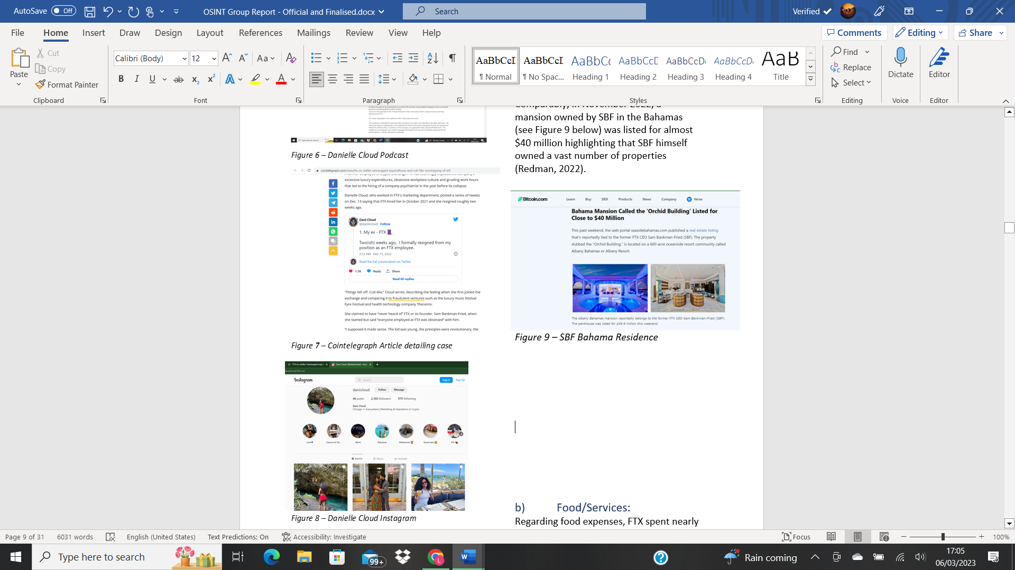

### Food/Services:

Across a 9-month period in 2022, where FTX generated $0 in revenue, FTX spent/expensed over $7m on food and services. This is how:

* $1m on a catering company
* Frequent $2,500 lunches for CEOs
* US Employees – daily $200 ‘DoorDash’ expense
* Bahama Employees – free food, bi-weekly massages, gas-inclusive automobiles & expensed travel to ANY FTX headquarters (business class)

### Travel:

FTX spent over $4.5m on travel and shipping:

* $4m on private flights
* $500,000 on postage and delivery expenses – this is because Amazon does not ship to the Bahamas, so privately rented planes were used to transport packages to its headquarters.

Additionally, there are reports that SBF owns a 52-foot yacht worth several million dollars (Ruiz, 2022).

### Marketing & Politics:

FTX spent a ridiculous amount of their finances on the marketing of FTX and political lobbying:

* $135m for the naming rights to the Miami Heat Arena
* $15m to Kevin O’Leary (FTX spokesperson)
* FTX Commercials, estimated $100m
* $93m on lobbying and ‘supporting’ of political parties

Court records revealed that Gisele Bundchen had 686,000 shares worth about $25 million, and Tom Brady controlled 1.1 million shares of FTX for their involvement in FTX commercials, according to sources from the New York Post and Forbes (Jones, 2022). The sums paid to Shaq O'Neil and countless other celebrities, including YouTubers, to promote FTX are unclear.

Nelson (2023) claims that FTX gave a total of $93 million in assistance to politicians and parties. According to reports, SBF allegedly sent out a large number of private letters to recover the given funds (Luscombe, 2023; "Unusual Political Trade," 2023).

# **Misuse of customer funds:**

"None of the Digital Assets in your Account are the property of, or shall or may be loaned to, FTX Trading; FTX Trading does not represent or regard Digital Assets in User's Accounts as belonging to FTX Trading," the (FTX, 2022) Terms of Service clearly state in section 8.2.6 > B. Experts had endorsed that (Cochran, 2022). Nevertheless, according to a Wall Street Journal story, FTX had utilised customer assets to finance dangerous trades (Haung et al., 2022).

# **Negative impact of Binance’s exit from FTX equity:**

As a result of a CoinDesk report (Allison, 2022), CZ, the CEO of Binance, had tweeted his decision to sell Binance’s share of FTT tokens (Figure 10), leading to the fall of FTT token by 86% falling from $14Billion in March to almost $825 million (Saul, 2022).

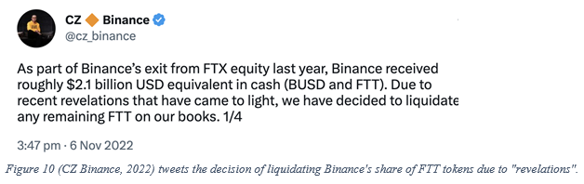

This ultimately flooded the market and caused chaos, beginning the never-ending withdrawal of FTX equity, crumbling the market and the company itself.

# **FTX Hack:**

According to Bourgi (2022), the net outflows from FTX and FTX US have considerably grown as a result of unlawful transactions, totaling $659, or one-third of their wallets' net outflows during the past seven days (Figure 11).

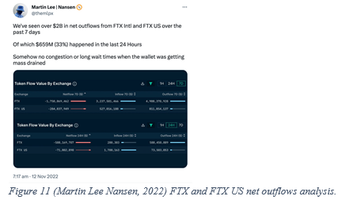

Robinson (2022), the co-founder of cryptocurrency investigative business Elliptic, claims that of the $659 million, $477 million in cryptocurrency assets were stolen from FTX on November 12th, and it was reported as a "hack" on FTX's Telegram channel (Figure 12). The "hack" back then was confirmed in a report by Jon Ray, the new CEO of FTX (Ligon, 2022).

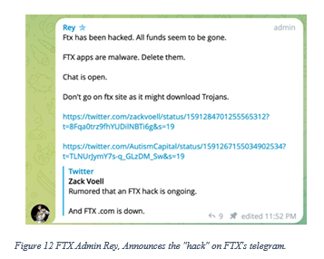

USDT and PAXG seized from FTX, totalling $100 million, were frozen. However, the remainder was converted into Ether using a decentralised exchange, which is frequently utilised to prevent asset seizures. On November 17th, the SCB declared that, to safeguard consumer cash, it had ordered the transfer of FTX assets to its wallet. Nevertheless, they were ambiguous about whether they were referring to the $477 million transferred on November 12th (Robinson, 2022). They may have meant the $280 million in fresh FTT and ETH that were transferred from FTX's wallets on November 13th, according to others (see picture figure 13).

(Scott Shafer, 2022) asserts that SCB directed SBF to turn the money over to their care. Intriguingly, FTX's lawyers (2022) filed an emergency motion to the court alleging that SCB had made SBF and Gary Wang transfer assets to their custody via ‘unauthorized access’.

 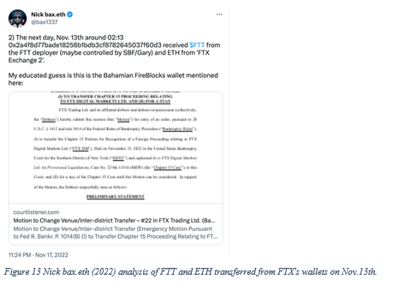

On November 20th, the remaining $477 that had been moved to ETH was converted into RenBTC first and then crossed to Bitcoin using the Ren Bridge, which Alameda Research had previously acquired (Robinson, 2022). The Elliptic research team (2022) claims that since the SCB was less likely to use this technique, which is frequently used in money laundering, they were more likely to bring up the $280 million transaction on November 13th (Robinson, 2022). The same information about the incidents was published in a CNBC story (Sigalos, 2022). Additionally, Hacken (2022), who had looked into the transactions at the time, said it in a CoinDesk piece (Ligon et al., 2022), and this is the link to the address that drained FTX wallets (https://etherscan.io/address/0x59ABf3837Fa962d6853b4Cc0a19513AA031fd32b) (see Figure 14).

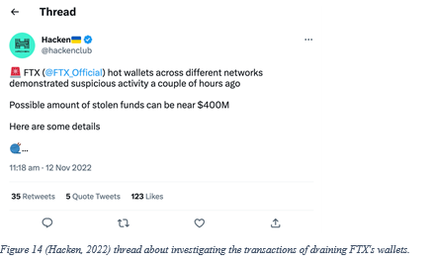

It may be an "inside job" (see Figure 15) because the looter had access to the cold wallets but was unable to move some money because they did not have enough TRX to pay the Tron blockchain's transaction fees. Instead, they transferred 500 TRX from their personal accounts on the Kraken exchange (Sandor, 2022). Although Kraken's CSO tweeted that they know the user's identity, it is unclear whether Kraken was requested to identify the account holder in accordance with their KYC policy (see Figure 15). Also, he tweeted that FTX or SBF would make a public statement about the Tron sweeping transactions (see Figure 16), but little had occurred. While some believe it could be an insider (see Figure 17), others believe it could be SBF (see Figure 18).

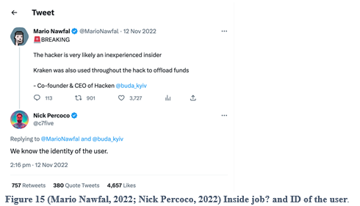

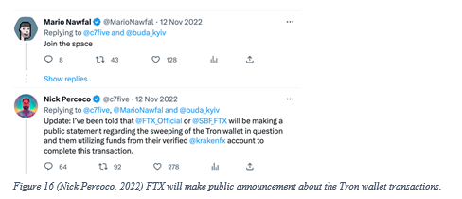

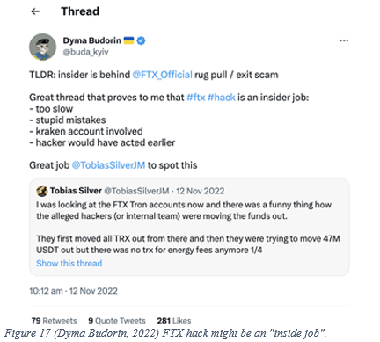

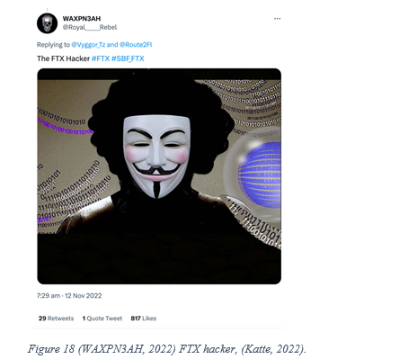

On 21/11/2022, a report by Cointelegraph demonstrates that, although the hacker dumped 50,000 ETH, he is still one of the top 40 ETH holders (Jha, 2022).

# **Comparison to other exchange crashes:**

## Luna:

Do Kwon, in contrast to SBF, is charismatic and narcissistic, which caused him to dominate decision-making, resulting in Terra Luna's collapse and the loss of millions of dollars (ColdFusion, 2022). Similar circumstances were seen in FTX, where SBF was exclusively in charge of significant decisions. Both crashes had massive withdrawals previous to the victims' deaths, which was something they had in common. It's interesting to note that the SEC had filed fraud complaints against Do Kwon (Morris, 2023) and SBF (Jha, 2022).

Last but not least, it is believed that the collapse of Luna was caused by an "attack" (Morris, 2022) or an inside job (see figure 19), similar to the FTX "hacker" stated before. Terra "was built to fail," according to a CoinDesk investigation (Morris, 2022). When Do Kwon was informed, he was conceited and did not accept the criticism or work to rectify it; instead, he teased the wealthy investors to kill Luna, which eventually happened (Coffezilla, 2022).

The FTX technology was not inherently flawed, but the way the business was operating, using Slack and QuickBooks to manage records, for example, was inadequate for a billion-dollar sector (Bloomberg Television, 2022).

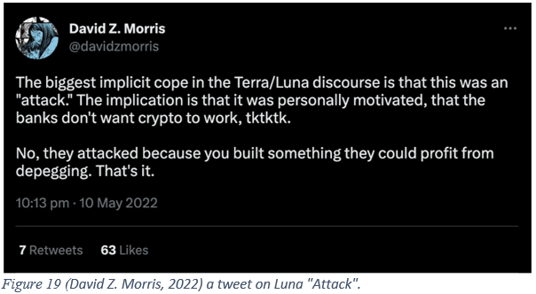

## Celsius:

## **Celsius Demise: Timeline of the Crypto Lender's Downfall.**

Celsius Network has declared bankruptcy because of falling cryptocurrency prices and uncertain market conditions. Its collapse occurred as follows (Napolitano, 2022; Reuters, 2023) :

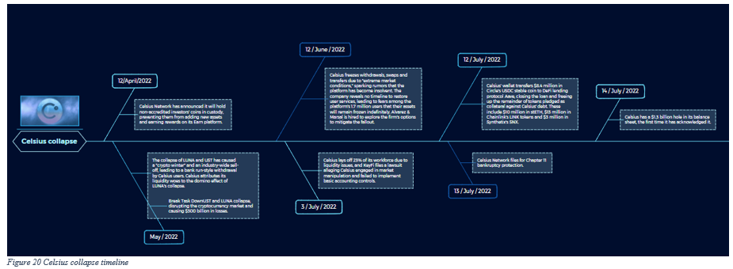

# **Recovered Assets:**

It is significant to highlight that FTX's recovery of monies does not imply that clients who suffered financial losses will receive complete compensation. It is unknown how much, if any, will be available for customers, as payment to creditors and stakeholders will normally take priority during the bankruptcy process.

The full scope of any alleged fraud or malfeasance has yet to be established, and judicial procedures against FTX and its former CEO are still pending.

But, as of late February 2023, FTX had rebounded:

* November 2022: Following the company's bankruptcy, $740 million in cryptocurrency was recovered (CBS News, 2022).
* January 2023: $5 billion in assets, according to Andy Dietderich, a lawyer for the business (Miller, 2023).



# **Timeline:**

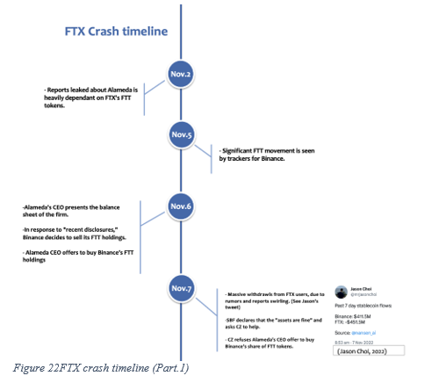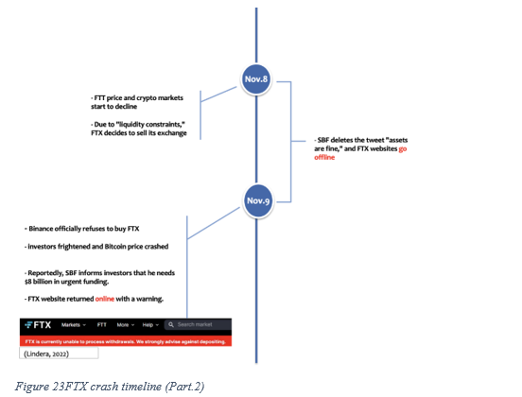

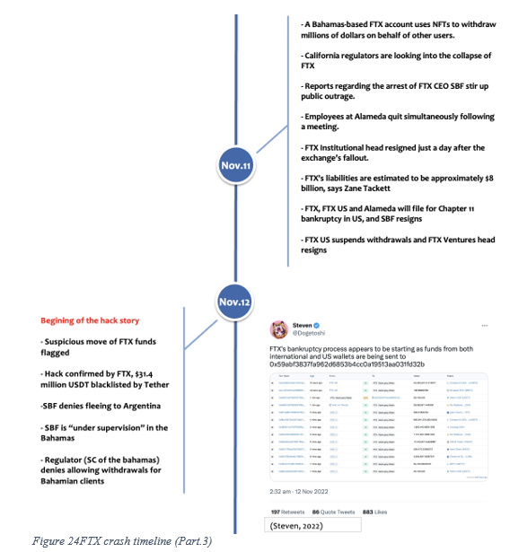

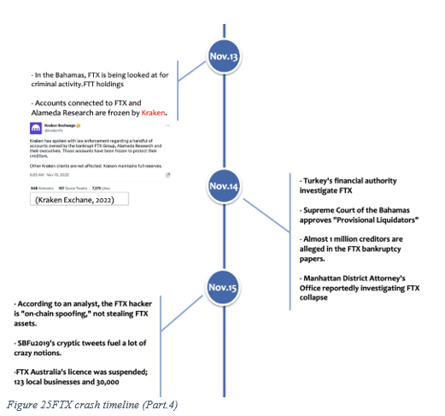

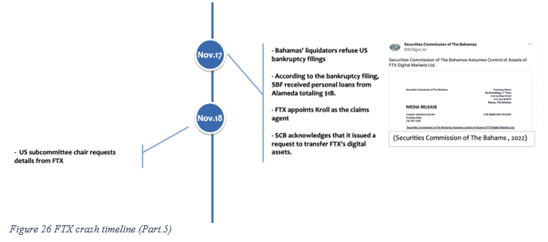

The main source for this diagram is a Cointelegraph post by Coghlan (2022), and a few additional articles from the same website were used to corroborate the events illustrated. (Pereira, 2022; Linderea, 2022; Wright, 2022; Fortis, 2022; Jenkinson, 2022). Also, additional tweets that were cited in the post were confirmed to be accurate on the Twitter website (Jason Choi, 2022; CZ Binance, 2022; Steven, 2022; Kraken Exchange, 2022; Securities Commission of The Bahamas, 2022).

To confirm the accuracy of one incident, an OSINT tool (Wayback Machine) was used. It was claimed that SBF tweeted "assets are fine" on November 7, 2022, and then removed the tweet one day later. While inspecting SBF’s Twitter, there was a tweet deleted on the same date (see figure 27).

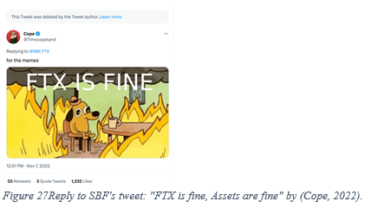

To view this tweet, a link to the @SBF_FTX Twitter account was checked with the Wayback Machine on November 8th, and the tweet was discovered to be true (Figure 28).

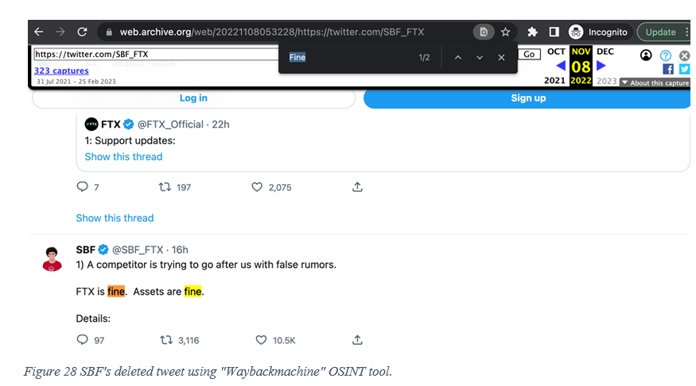

# **Collective development of an OSINT toolkit:**

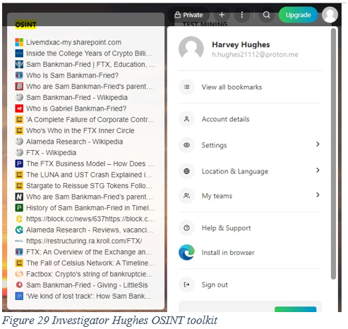

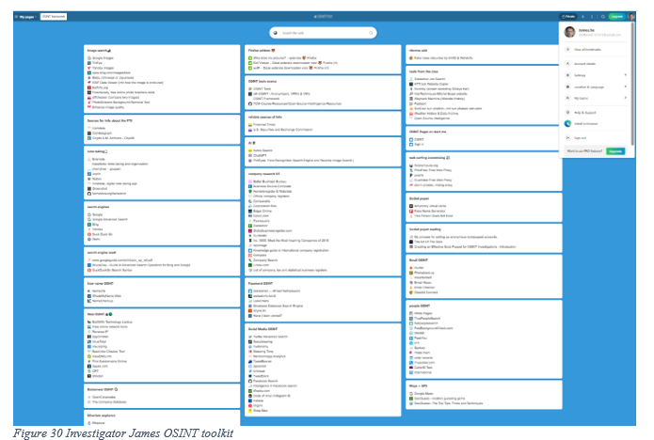

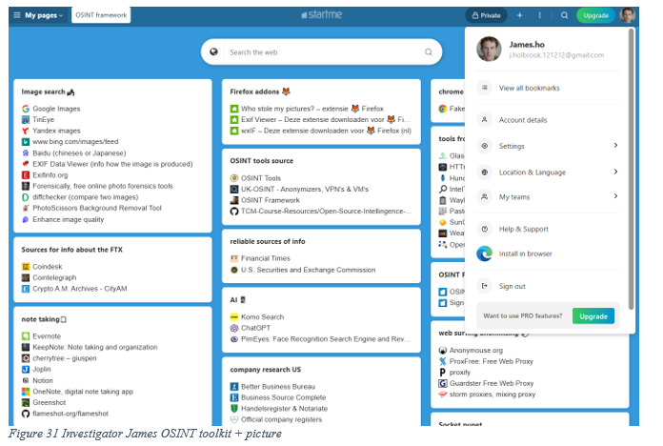

# **FTX investigation visual story board:**

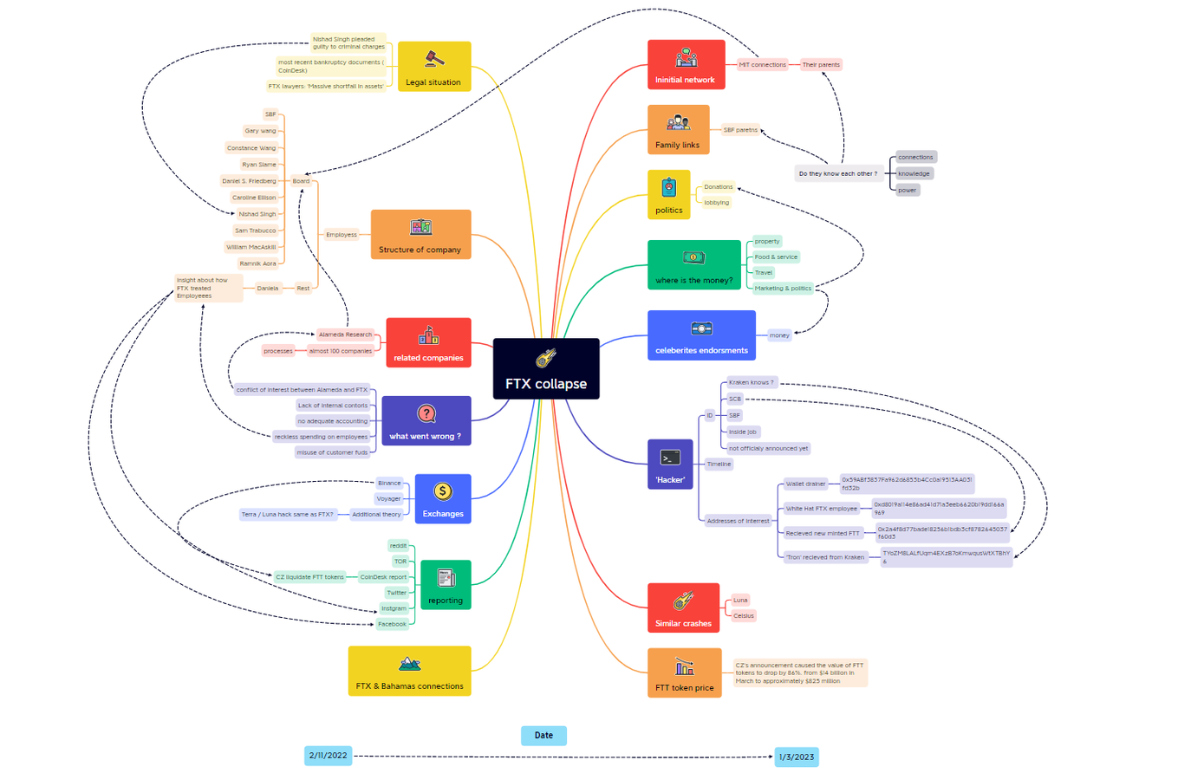

Figure 32 FTX collapse investigation visual story board.

# **Conclusion**

Ultimately, our team was not able to cover all aspects of the collapse due to time limitations. But it is currently implausible to draw the conclusion that this situation involved a planned internal attack. We have thoroughly examined and reported on our findings, as well as what we believe went wrong that might have contributed to the bankruptcy. We encourage you to wait for the conclusion of the present legal proceedings to avoid being in contempt of court.

# **Table of Figures**

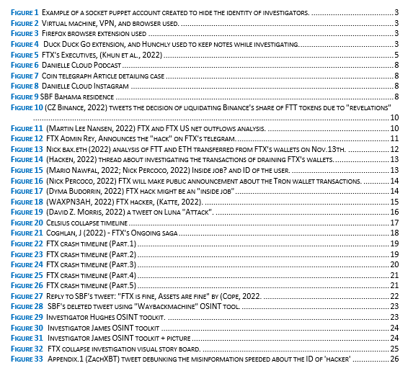

# **Appendix**

## Appendix 1: block chain investigator debunks common misinformation about the ID of FTX hack.

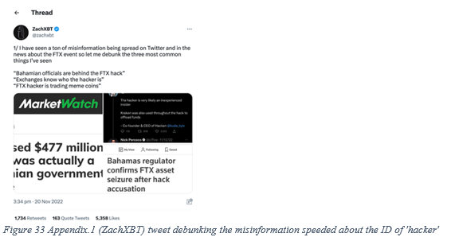

## Appendix 2: further investigation leads

1. any fraudulent connections between SBF and his parents.

1. While SBF's parents, who are professors of law, could not properly advise him despite his dad working as an FTX employee at the early stage.
2. Caroline's parents, who are economist professors and lecturers at MIT, were unable to assist her in steering the ship of Alameda as CEO before she drove the company bankrupt.
3. Addresses of interest could be monitored for more information that might come in the future, it is retrieved From Nick.bax.eth (2022) tweet:
4. “FTX Wallet Drainer”

0x59ABf3837Fa962d6853b4Cc0a19513AA031fd32b

1. “White hat FTX employee”

0xd8019a114e86ad41d71a3eeb6620b19dd166a969

1. “Received FTT from FTT deployer” Maybe the SCB

0x2a4f8d77bade18256b1bdb3cf8782645037f60d3

1. “TRX address” that received a transfer from a Kraken account:

[TYoZM8LALfUqm4EXzB7oKmwqusWtXTBhY6](https://tronscan.org/%22%20/l%20%22/address/TYoZM8LALfUqm4EXzB7oKmwqusWtXTBhY6)

# **References:**

Alameda Research (2022) Reviews, vacancies, news, personalities. Companies of New York. *New York Business portal*. Available at: <https://www.globalny.biz/catalog/id/3211> (Accessed: February 24, 2023).

*Alameda Research* (2023) *Wikipedia*. Wikimedia Foundation. Available at: <https://en.wikipedia.org/wiki/Alameda_Research> (Accessed: February 20, 2023).

Allison, I (2022) ‘Divisions in Sam Bankman-Fried’s Crypto Empire Blur on His Trading Titan Alameda’s Balance Sheet’ CoinDesk 2 November. Available at: <https://www.coindesk.com/business/2022/11/02/divisions-in-sam-bankman-frieds-crypto-empire-blur-on-his-trading-titan-alamedas-balance-sheet/> (Accessed: 24 February 2023).

*Block.cc-checking before investing cryptocurrency* (2022) *The Who's Who of the FTX Inner Circle*. Available at: <https://block.cc/> (Accessed: February 24, 2023).

Bloomberg Television (2022) FTX Used Slack and QuickBooks to Keep Records: Ray. Available at: <https://www.youtube.com/watch?v=Hr4Lmn3Oht8> (Accessed: 27 February 2023).

Bourgi, S (2022) ‘FTX reportedly hacked as officials flag abnormal wallet activity’ *Cointelegraph* 12 November. Available at: <https://cointelegraph.com/news/ftx-reportedly-hacked-as-officials-flag-abnormal-wallet-activity> (Accessed: 27 February 2023).

Calhoun, G. (2022). *FTX and ESG: a Panorama of Failed Governance (Pt 1 – the Internal Failures)*. [online] Forbes. Available at: <https://www.forbes.com/sites/georgecalhoun/2022/11/21/ftx-and-esg-a-panorama-of-failed-governance-pt-1--the-internal-failures/?sh=6f739ee92d9d> [Accessed 25 Feb. 2023].

CBS News (2022). *$740 Million in Crypto Assets Recovered in FTX Bankruptcy*. [online] Available at: <https://www.cbsnews.com/news/ftx-trading-bankruptcy-recovered-funds-assets/>. (Accessed: 28 February 2023).

Chainalysis (2022) [Twitter] 20 November. Available at: <https://twitter.com/chainalysis/status/1594349583416840199> (Accessed: 27 February 2023).

Cochran, A. (2022) *FTX TOS*, *Twitter*. Twitter. Available at: <https://twitter.com/adamscochran/status/1589965560611164160> (Accessed: February 13, 2023).

Coffezilla (2022) How Luna Collapsed. Available at: <https://www.youtube.com/watch?v=LVanuXZedbs> (Accessed: 27 February 2023).

Coghlan, J. (2022) ‘FTX’s ongoing saga: Everything that’s happened until now’ *Cointelegraph* 10 November. Available at: <https://cointelegraph.com/news/ftx-and-binance-s-ongoing-saga-everything-that-s-happened-until-now> (Accessed: 24 February 2023).

*CoinDesk on binance feed: Who is Alameda Research's Caroline Ellison?* (2022) *Binance Feed*. Available at: <https://www.binance.com/kk-KZ/feed/post/82171> (Accessed: February 24, 2023).

Cointelegraph. (2022). *FTX was an ‘utter failure of corporate controls at every level of an organization’, says new CEO*. [online] Available at: <https://cointelegraph.com/news/ftx-was-an-utter-failure-of-corporate-controls-at-every-level-of-an-organization-says-ceo> [Accessed 25 Feb. 2023].

ColdFusion (2022) How This Man Just Caused a $45 BILLION Crash [Terra Luna]. Available at: <https://www.youtube.com/watch?v=3KZY41SqaTI&t=11s> (Accessed: 27 February 2023).

*Constance Wang* (2023) LinkedIn profile. Available at:  <https://bs.linkedin.com/in/constancewz?trk=people-guest_people_search-card> (Accessed: 19 Feb 2023).

Cope (2022) [Twitter] November 7. Available at: <https://twitter.com/Timccopeland/status/1589601511503716352?s=20&t=43s8MGfILWpYE06yTJobDA> (Accessed 26 February 2023).

CZ Binance. (2022) [Twitter] 10 November. Available at: <https://twitter.com/cz_binance/status/1590698521195610113?lang=en> (Accessed: 24 February 2023).

CZ Binance. (2022) [Twitter] 6 November. Available at: <https://twitter.com/cz_binance/status/1589283421704290306?ref_src=twsrc%5Etfw> (Accessed: 24 February 2023).

David Z. Morris (2022) [Twitter] 10 May. Available at: <https://twitter.com/davidzmorris/status/1524135681005604867> (Accessed: 27 February 2023).

Devanshu (2022) *Who is Gabriel Bankman-fried?*, *Opoyi*. Available at: <https://opoyi.com/technology/who-is-gabriel-bankman-fried-827684/> (Accessed: February 19, 2023).

Donlevy, K. (2022) *Who are Sam Bankman-Fried's parents? meet law professors Joseph and Barbara*, *New York Post*. New York Post. Available at: <https://nypost.com/2022/12/14/who-are-sam-bankman-frieds-parents-meet-joseph-and-barbara/> (Accessed: February 19, 2023).

Dyma Budorin (2022) [Twitter] 12 November. Available at: <https://twitter.com/buda_kyiv/status/1591373373900173312> (Accessed 27 February 2023).

Elliptic research team (2022) ‘Cross-chain Crime: More Than Half a Billion Dollars has Been Laundered Through a Cross-chain Bridge’ *Elliptic Connect* 10 August. Available at: <https://hub.elliptic.co/analysis/cross-chain-crime-more-than-half-a-billion-dollars-has-been-laundered-through-a-cross-chain-bridge/> (Accessed: 26 February 2023).

FDIC (2022) *Press releases 2022*, *FDIC*. Available at: <https://www.fdic.gov/news/press-releases/2022/ftx-harrison-letter.pdf?source=govdelivery&utm_medium=email&utm_source=govdelivery> (Accessed: February 9, 2023).

Fortis, S. (2022) ‘FTX bankruptcy filing speculates over 1M creditors’ *Cointelegraph* 15 November. Available at: <https://cointelegraph.com/news/ftx-bankruptcy-filing-speculates-over-1-million-creditors> (Accessed: 26 February 2023).

FTX (2022) Terms of Services 13 May 2022. Available at: <https://gighustlers.com/wp-content/uploads/2022/11/httpshelp.ftx_.comhcarticle_attachments9719619779348FTX_Terms_of_Service.pdf> (Accessed: 8 February 2023).

FTX (2022) [Twitter] 20 November. Available at: <https://twitter.com/ftx_official/status/1594354846370758657> (Accessed: 2 March 2023)

*FTX* (2023) *Wikipedia*. Wikimedia Foundation. Available at: <https://en.wikipedia.org/wiki/FTX#:~:text=The%20exchange%20was%20founded%20in,and%20headquartered%20in%20the%20Bahamas>. (Accessed: February 20, 2023).

FTX lawyers (2022) ‘EMERGENCY MOTION PURSUANT’ [PDF file] Available at: <https://pacer-documents.s3.amazonaws.com/33/188450/042120648186.pdf> (Accessed: 26 February 2023).

Goswami, M.S. (2022). *FTX Spent $256 Million on Bahamas Real Estate — Now the island’s Government Wants It Back*. [online] CNBC. Available at: <https://www.cnbc.com/2022/12/12/ftx-sam-bankman-fried-snapped-up-256-million-in-bahamas-real-estate.html> [Accessed 25 Feb. 2023].

Hacken (2022) [Twitter] 12 November. Available at: <https://twitter.com/hackenclub/status/1591389942894456833> (Accessed: 27 February 2023).

Haung, V ,  Osipovich, A, and  Kowsmann, P. 2022 'FTX Tapped Into Customer Accounts to Fund Risky Bets, Setting Up Its Downfall', *The Wall Street Journal*, 11 November. Available at: <https://www.wsj.com/articles/ftx-tapped-into-customer-accounts-to-fund-risky-bets-setting-up-its-downfall-11668093732> (Accessed: 8 February 2023).

Hendelmann, V. (2022) *The FTX Business Model – How does FTX make money?*, *productmint*. Available at: <https://productmint.com/ftx-business-model-how-does-ftx-make-money/> (Accessed: February 20, 2023).

*History of Sam Bankman-fried in timeline - popular timelines* (2022) *populartimelines.com*. Available at: <https://populartimelines.com/timeline/Sam-Bankman-Fried> (Accessed: February 24, 2023).

Indap, s. (2022) ‘John Ray III, the firefighter drafted in to quell the FTX crisis’ Financial Times. 16 December. Available at: <https://www.ft.com/content/09a9c233-8226-40d8-9fa4-6af735e408ca> (Accessed 19 Feb 2023).

J. Brooks, K. (2022). *FTX’s New CEO: ‘Never in My Career Have I Seen Such a Complete failure’*. [online] www.cbsnews.com. Available at: <https://www.cbsnews.com/news/ftx-bankruptcy-john-ray-ceo-failure/> (Accessed: 26 February 2023).

Jason Choi (2022) [Twitter] 7 November. Available at: <https://twitter.com/mrjasonchoi/status/1589541601801801729> (Accessed 26 February 2023).

Jenkinson, G. (2022) ‘SBF received $1B in personal loans from Alameda: FTX bankruptcy filing’ *Cointelegraph* 17 November. Available at: <https://cointelegraph.com/news/sbf-received-1-billion-in-personal-loans-from-alameda-ftx-bankrupty-filing> (Accessed 26 February 2023).

Jha, P (2022) ‘FTX hacker dumps 50,000 ETH, still among top 40 Ether holders’ Cointelegraph 21 November. Available at: <https://cointelegraph.com/news/ftx-hacker-dumps-50-000-eth-still-among-top-40-ether-holders> (Accessed: 2 March 2023)

Jha, P (2022) ‘SEC charges former FTX CEO SBF for defrauding investors a day after his arrest’ *Cointelegraph* 13 December. Available at: <https://cointelegraph.com/news/sec-charges-ftx-ceo-sbf-for-defrauding-investors-a-day-after-the-arrest> (Accessed: 27 February 2023).

Jones, D. (2023). *Tom Brady’s FTX Shares Were Once Worth $45 million. Will He Lose It all?* [online] Morningstar, Inc. Available at: <https://www.morningstar.com/news/marketwatch/20230117346/tom-bradys-ftx-shares-were-once-worth-45-million-will-he-lose-it-all> [Accessed 25 Feb. 2023].

Kamarul, H (2022) ‘**‘**Spoof’ Tokens on Ethereum**’** *Etherscan Blog* 10 March. Available at: <https://medium.com/etherscan-blog/spoof-tokens-on-ethereum-c2ad882d9cf6> (Accessed: 27 February 2023).

Katte, S (2022) ‘Crypto sleuth debunks 3 biggest misconceptions about the FTX hack’ *Cointelegraph* 21 November. Available at: <https://cointelegraph.com/news/crypto-sleuth-debunks-3-biggest-misconceptions-about-the-ftx-hack> (Accessed: 27 February 2023).

Kraken Exchange (2022) [Twitter] 13 November. Available at: <https://twitter.com/krakenfx/status/1591678095840641025?lang=en> (Accessed: 24 February 2023).

Kuhn, D, Luo, X, and Morris, D. (2022) ‘ Who’s who in the FTX inner circle’ CoinDesk, 22 November. Available at: <https://www.coindesk.com/layer2/2022/11/22/the-whos-who-of-the-ftx-inner-circle/> (Accessed: 20 February 2023).

Ligon, C (2022) ‘FTX CEO John Ray Confirms Late-Night Hack, Says Company Is Working With Law Enforcement’ *CoinDesk* 12 November. Available at: <https://www.coindesk.com/policy/2022/11/12/ftx-ceo-john-ray-confirms-late-night-hack-says-company-is-working-with-law-enforcement/> (Accessed: 27 February 2023).

Ligon, C, Reynolds, S, Kessler, S, De, N, and Decker, R (2022) ‘'FTX Has Been Hacked': Crypto Disaster Worsens as Exchange Sees Mysterious Outflows Exceeding $600M’ *CoinDesk* 12 November. Available at: <https://www.coindesk.com/business/2022/11/12/ftx-crypto-wallets-see-mysterious-late-night-outflows-totalling-more-than-380m/> (Accessed: 27 February 2023).

Linderea, B. (2022) ‘ FTX website comes back online with message advising against deposits**’** *Cointelegraph* 10 November. Available at: <https://cointelegraph.com/news/ftx-website-comes-back-online-with-message-advising-against-deposits> (Accessed: 24 February 2023).

Linderea, B. (2022) ‘ Sequoia Capital marks down entire $214M FTX stake to zero’ *Cointelegraph* 10 November. Available at : <https://cointelegraph.com/news/sequoia-capital-marks-down-entire-214m-ftx-stake-to-zero> (Accessed: 24 February 2023).

Luscombe, R. (2023). Bankrupt FTX exchange asks for its political donations to be returned. *The Guardian*. [online] 6 Feb. Available at: <https://www.theguardian.com/business/2023/feb/06/ftx-exchange-sam-bankman-fried-donations> [Accessed 25 Feb. 2023].

Mario Nawfal (2022) [Twitter] 12 November. Available at: <https://twitter.com/MarioNawfal/status/1591421392142368768> (Accessed 27 February 2023).

Martin Lee Nansen (2022) [Twitter] 12 November. Available at: <https://twitter.com/themlpx/status/1591329438746447875> (Accessed: 27 February 2023).

McKenna, F. (2022). *‘A Complete Failure of Corporate Controls’: What Investors and Accountants Missed in FTX’s Audits*. [online] www.coindesk.com. Available at: <https://www.coindesk.com/layer2/2022/11/18/a-complete-failure-of-corporate-controls-what-investors-and-accountants-missed-in-ftxs-audits/> [Accessed 25 Feb. 2023].

Miller, M. (2023). FTX: Collapsed crypto giant recovers over $5bn of assets. *BBC News*. [online] 12 Jan. Available at: <https://www.bbc.co.uk/news/business-64245044> [Accessed 25 Feb. 2023].

Mishra, P, and Schickler, J. (2022) ‘US SEC Charges Sam Bankman-Fried for Defrauding FTX Investors’ CoinDesk, 13 December. Available at: <https://www.coindesk.com/policy/2022/12/13/us-sec-charges-sam-bankman-fried-for-defrauding-ftx-investors/> (Accessed: 24 February 2023).

Morris, D (2022) ‘Built to Fail’? Why TerraUSD’s Growth Is Giving Finance Experts Nightmares’ *CoinDesk* 22 April. Available at: <https://www.coindesk.com/layer2/2022/04/22/built-to-fail-why-terrausds-growth-is-giving-finance-experts-nightmares/> (Accessed: 27 February 2023).

Morris, D (2022) ‘There Was No Terra ‘Attack’’ *CoinDesk* 20 May. Available at: <https://www.coindesk.com/layer2/2022/05/20/there-was-no-terra-attack/> (Accessed: 27 February 2023).

Morris, D (2023) ‘4 Huge Revelations in the SEC’s Charges Against Do Kwon and Terraform Labs’ *CoinDesk* 17 February. Available at: <https://www.coindesk.com/consensus-magazine/2023/02/17/4-huge-revelations-in-the-secs-charges-against-do-kwon-and-terraform-labs/> (Accessed: 27 February 2023).

Mostarac, A. (2022) [Twitter] 15 November. Available at <https://twitter.com/anammostarac/status/1592346187553968129?s=20> (Accessed: 19 Feb 2023).

Napolitano, E. (2022) *The fall of celsius network: A timeline of the crypto lender's descent into insolvency*, *CoinDesk Latest Headlines RSS*. CoinDesk. Available at: <https://www.coindesk.com/markets/2022/07/15/the-fall-of-celsius-network-a-timeline-of-the-crypto-lenders-descent-into-insolvency/> (Accessed: February 27, 2023).

Nelson, D. (2023). *FTX Asks Politicians Who Received Bankman-Fried Donations to Return Money*. [online] www.coindesk.com. Available at: <https://www.coindesk.com/policy/2023/02/05/ftx-asks-politicians-who-received-bankman-fried-donations-to-return-money/> [Accessed 25 Feb. 2023].

Nick bax.eth (2022) [Twitter] 17 November. Available at: <https://twitter.com/bax1337/status/1593384595994468352?t=AMnz9_gmKgz1B5kmUesH4Q&s=19> (Accessed: 26 February 2023).

Nick Percoco (2022) [Twitter] 12 November. Available at: <https://twitter.com/c7five/status/1591434844760076290>  (Accessed: 26 February 2023).

Oliver, J, and Shubber, K. (2022) ‘Sam Bankman-Fried’s hedge fund took big hit to prop up FTX exchange’ Financial Times, 2 December. Available at : <https://www.ft.com/content/5e9dc424-aef4-4981-a4d7-e3c40e1e6085> (Accessed: 20 February 20223).

Oliver,J, Asgari, N, and Shubber, K. (2022) ‘FTX: inside the crypto exchange that ‘accidentally’ lost $8bn’ Financial Times, 18 November. Available at: <https://www.ft.com/content/913ff750-d1f4-486a-9801-e05be20041c1> (Accessed: 20 February 2023).

*Pereira, A. (2022) ‘Alameda* Research and FTX Ventures websites go dark’ *Cointelegraph* 9 November. Available at: <https://cointelegraph.com/news/alameda-s-research-and-ftx-ventures-websites-taken-down> (Accessed: 24 February 2023).

Pereira, A. (2022) ‘Turkey’s financial authority investigates FTX’s collapse’ *Cointelegraph* 14 November. Available at: <https://cointelegraph.com/news/turkey-s-financial-authority-investigates-ftx-s-collapse> (Accessed: 26 February 2023).

Person (2023) *Factbox: Crypto's string of bankruptcies*, *Reuters*. Thomson Reuters. Available at: <https://www.reuters.com/business/finance/cryptos-string-bankruptcies-2023-01-20/> (Accessed: February 27, 2023).

Post, N.Y. (2022) *Who are Sam Bankman-Fried's parents? meet law professors Joseph and Barbara*, *DNyuz*. DNYUZ. Available at: <https://dnyuz.com/2022/12/14/who-are-sam-bankman-frieds-parents-meet-law-professors-joseph-and-barbara/> (Accessed: February 24, 2023).

Redman, J. (2022). *Effective Altruism: Former FTX CEO’s Alleged $40M Penthouse Listed for Sale, Report Says Firm Spent $74M on Real Estate – Bitcoin News*. [online] news.bitcoin.com. Available at: <https://news.bitcoin.com/effective-altruism-former-ftx-ceos-alleged-40m-penthouse-listed-for-sale-report> says-firm-spent-74m-on-real-estate/ [Accessed 25 Feb. 2023].

Richards,c. (2023) ‘ Before FTX: A Look Back at the Ultimate Bet & Absolute Poker Superusing Scandal’ Pokernews 1 January. Available at: <https://www.pokernews.com/news/2022/11/ultimate-bet-scandal-42623.htm> (Accessed 20 Feb 2023).

Robinson, T (2022) ‘$477 Million in “Unauthorized Transfers” from FTX’ *Elliptic Connect.* Available at: <https://hub.elliptic.co/analysis/477-million-in-unauthorized-transfers-from-ftx/> (Accessed: 26 February 2023).

Rosenberg, E. (2023) *Who is Sam Bankman-fried?*, *Investopedia*. Investopedia. Available at: <https://www.investopedia.com/who-is-sam-bankman-fried-6830274> (Accessed: February 19, 2023).

Ruiz, M. (2022). *Fallen FTX Boss Spent Lavishly in Bahamas While Allegedly Misusing Customer Funds*. [online] FOXBusiness. Available at: <https://www.foxbusiness.com/lifestyle/fallen-ftx-boss-spent-lavishly-bahamas-while-allegedly-misusing-customer-funds> [Accessed 25 Feb. 2023].

*Sam Bankman-Fried* (2023) *Encyclopædia Britannica*. Encyclopædia Britannica, inc. Available at: <https://www.britannica.com/biography/Sam-Bankman-Fried> (Accessed: February 19, 2023).

Sandor, K (2022) ‘FTX Hack or Inside Job? Blockchain Experts Examine Clues and a ‘Stupid Mistake’’ *CoinDesk* 14 November. Available at: <https://www.coindesk.com/business/2022/11/14/ftx-hack-or-inside-job-blockchain-experts-examine-clues-and-a-stupid-mistake/> (Accessed: 27 February 2023).

Saul, D (2022) ‘Binance Bails On FTX Acquisition — Here’s What Led To The FTX Crypto Crash’ Forbes Digital Assets. 10 November. Available at: <https://www.forbes.com/sites/dereksaul/2022/11/09/binance-reportedly-bails-on-ftx-acquisition---heres-what-led-to-the-ftx-crypto-crash/> (Accessed: 24 February 2023).

Scott Shafer (2022) FTX Hacker FOUND! Government Involved! - Crypto Hacker**.** Available at: <https://www.youtube.com/watch?v=5x4000HyaBM> (Accessed 27 February 2023).

Securities Commission of The Bahamas (2022) [Twitter] 18 November. Available at: <https://twitter.com/SCBgov_bs/status/1593395137786171393> (Accessed: 26 February 2023).

Sigalos, M (2022) ‘FTX says it’s removing trading and withdrawals, moving digital assets to a cold wallet after a $477 million suspected hack’ *CNBC* 12 November.Available at: <https://www.cnbc.com/2022/11/12/ftx-says-its-removing-trading-and-withdrawals-moving-digital-assets-to-a-cold-wallet-after-a-477-million-suspected-hack.html> (Accessed: 27 February 2023)**.**

Smith, T. (2023) *FTX: An overview of the exchange and its collapse*, *Investopedia*. Investopedia. Available at: <https://www.investopedia.com/ftx-exchange-5200842> (Accessed: February 24, 2023).

Steven (2022) [Twitter] 12 November. Available at: <https://twitter.com/Dogetoshi/status/1591257685441515521?ref_src=twsrc%5Etfw> (Accessed: 24 February 2023).

U.S. Securities and Exchange Commission (SEC), (2022), press release: SEC Charges Samuel Bankman-Fried with Defrauding Investors in Crypto Asset Trading Platform FTX. Available at: <https://www.sec.gov/news/press-release/2022-219> (Accessed: 24 February 2023).

unusualwhales.com. (2023). *Unusual Political Trading*. [online] Available at: <https://unusualwhales.com/politics/article/senate_ftx> [Accessed 25 Feb. 2023].

Wall Street Millennial (2023) FTX Executive's Involvements in Online Poker Scam Revealed. Available at: <https://www.youtube.com/watch?v=JpTXZLUn6iM> (Accessed 20 February 2023).

WAXPN3AH (2022) [Twitter] 12 November.  Available at: <https://twitter.com/Royal_____Rebel/status/1591332280500654080> (Accessed 27 February 2023).

Wright, T. (2022) ‘Bahamas’ supreme court approves ‘provisional liquidators’ for FTX’ *Cointelegraph* 15 November. Available at: <https://cointelegraph.com/news/bahamas-supreme-court-approves-provisional-liquidators-for-ftx> (Accessed: 26 February 2023).

ZachXBT (2022) [Twitter] 20 November. Available at: <https://twitter.com/zachxbt/status/1594353588872044549> (Accessed: 27 February 2023).